1: Grade Checker

Code:

# Grade Checker

marks = int(input("Enter your marks: "))

if marks >= 90:
print("Grade: A")
elif marks >= 80:
print("Grade: B")
elif marks >= 70:
print("Grade: C")
elif marks >= 60:
print("Grade: D")
else:
print("Grade: F")

Output:

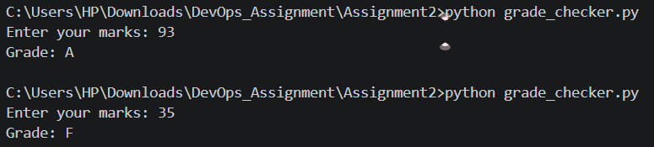

Explanation:

- Takes marks as input.
- Uses if-elif-else statements.
- Prints the corresponding grade.

2: Student Grades Using Dictionary

Code:

# Student Grades Dictionary

students = {}

while True:
print("\n1. Add Student")
print("2. Update Grade")
print("3. Display All Grades")
print("4. Exit")

choice = input("Enter choice: ")

if choice == "1":
name = input("Enter student name: ")
grade = input("Enter grade: ")
students[name] = grade
print("Student added successfully.")

elif choice == "2":
name = input("Enter student name: ")

if name in students:
grade = input("Enter new grade: ")
students[name] = grade
print("Grade updated successfully.")
else:
print("Student not found.")

elif choice == "3":
print("\nStudent Grades:")
for name, grade in students.items():
print(name, ":", grade)

elif choice == "4":
print("Program Ended")
break

else:
print("Invalid Your Choice")
Output:

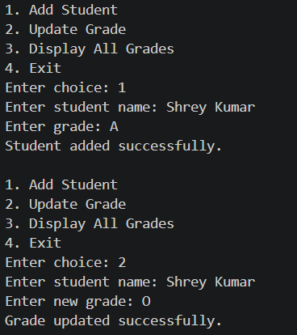
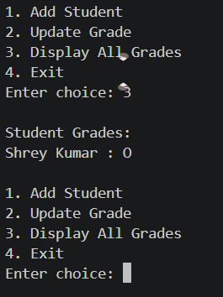
Explanation:

- Dictionary stores student names and grades.
- Allows adding new students.
- Allows updating grades.
- Displays all records.

3: Write to a File.

Code:

# Writing into a file

file = open("sample.txt", "w")

file.write("I am learning DevOps Concepts.\n")
file.write("This file is created using Python.\n")

file.close()

print("Data written successfully.")
Output:

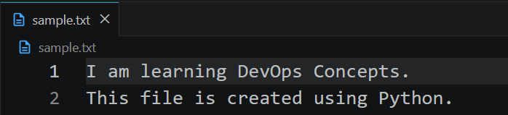
Explanation:

- open() creates the file.
- write() writes data.
- close() saves and closes the file.

4: Read from a File.

Code:

# Reading from a file

file = open("sample.txt", "r")

content = file.read()

print("File Content:")
print(content)

file.close()
Output:

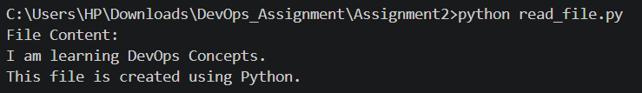
Explanation:

- Open file in read mode (r).
- Reads entire content using read().
- Displays content on screen.

Github Repository Link: https://github.com/sushilkumar121225/devops-assignments

